IMMANUEL ARASAR COLLEGE OF EDUCATION
Student Satisfaction Survey –B.Ed & M.Ed
Academic Year – 2017-18

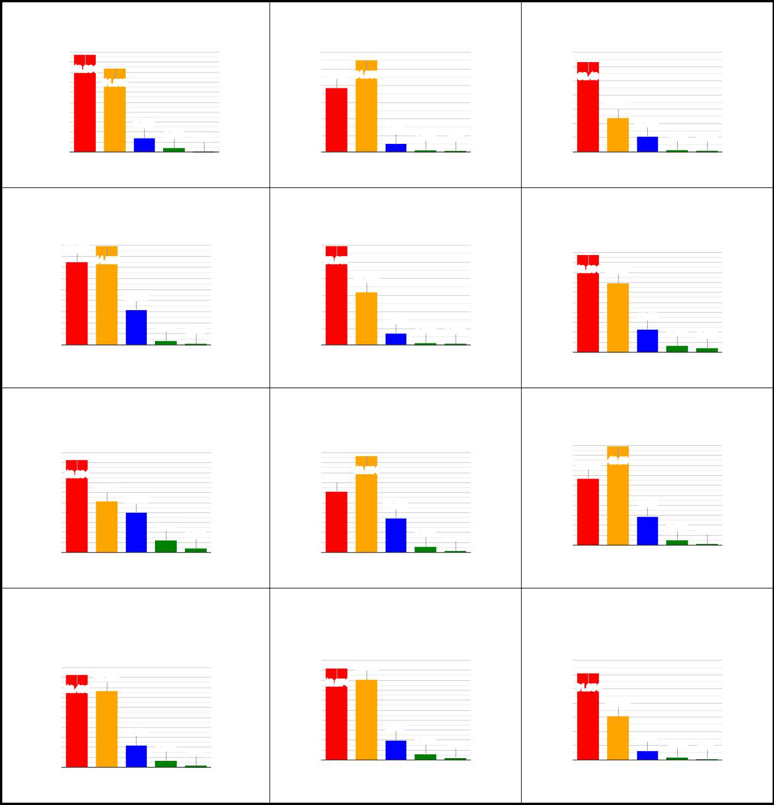
Q1. Syllabus Covered

Q2. Teachers' preparation for the classes

Q3. Teachers' ability of communication

50
45
40 48.864
# Percentage
35
30
25
20
15
10
5
0

41.839

7.025

2.066 0.207
60
50 38.43 54.959
# Percentage
40
30
20
10
0

4.959
1.033 0.62
70
60
50 63.43
# Percentage
40
30
20
10
0

23.864

10.537

1.343 0.826

4 3 2 1 0
# Ratings

Q4. Teachers' approach to teaching
4 3 2 1 0
# Ratings

Q5. Fairness of internal evaluation process
4 3 2 1 0
# Ratings

Q6. Discussion of performance in assignment with students

45 37.397
40
35
# Percentage
30
25
20
15
10
5
0

44.525

15.599

1.963 0.517
60
50 59.607
# Percentage
40
30
20
10
0

31.508

7.025

1.136 0.723

50
45
40 48.864 34.607
# Percentage
35
30
25
20
15
10
5

11.26

3.202 2.066

4 3 2 1 0
# Ratings

Q7. Institute's interest in promoting internship, student exchange, field visit
4 3 2 1 0
# Ratings

Q8. Teaching and Mentoring for cognitive, social & emotional growth
0
4 3 2 1 0
# Ratings

Q9. Multiple opportunities to learn and grow

50 50
45 45
50
45
40 33.368
# Percentage

49.69

40 46.384
# Percentage
35
30
25
20
15
10
5

25.517

19.938

6.095

2.066
40 48.554
35 30.475
# Percentage
30
25
20
15
10
5

17.252

2.996 0.723
35
30
25
20 14.05
15
10
5
0

2.376

0.517

0
4 3 2 1 0
# Ratings
0
4 3 2 1 0
# Ratings
4 3 2 1 0
# Ratings

Q10. Teachers' information about expected
competencies, course outcomes and programme outcomes

Q11. The necessary follow-up with an assigned task

Q12. Teachers' illustration of the concepts through examples and applications

50 70

50
45 40.186

45
40 46.488
# Percentage
35
30
25
20
15
10
5
38.326

11.157

3.099 0.93
40 46.074
35
# Percentage
30
25
20
15
10
5
0

9.917

2.893

0.93
60
50 61.054
# Percentage
40
30
20
10
0

30.579

6.405

1.653 0.31

0
4 3 2 1 0
# Ratings
4 3 2 1 0
# Ratings
4 3 2 1 0
# Ratings

Page 1 of 2

# Percentage
# Percentage
# Percentage
# Percentage
# Percentage
# Percentage

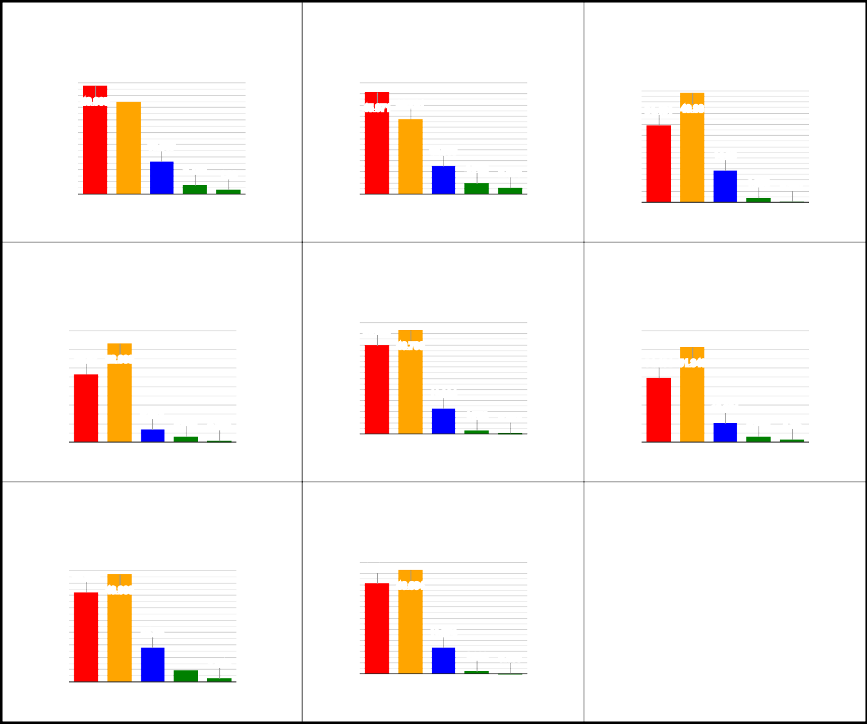** Numbers indicated in X-Axis=Response Score and Number on top of bar indicates percentage of students evaluated.
Q13. Identification of students' strength and Q14. Identification of students' weakness and Q15. The institute's engagement of students in encouragement remedial measures the monitoring, review and continuous quality
improvement
45
40
35
30
25
20
15
10
5
0
50
45
43.905
37.5
45.971 33.781
13.017
40
35
30
25
20
15
10
5
0
50
45
40
35
30
25
20
15
10
5
0
34.401 49.38
12.603
14.05
3.719
1.86
4.752 2.893
1.963 0.207
4 3
2
# Ratings
1 0
4 3
2
# Ratings
1 0
4 3
2 1
# Ratings
0
Q16. Use of student-centric methods, such as Q17. Teachers' encouragement of students to Q18. Institute/Teachers inculcating soft skills, experiential learning, participative learning and participate in extracurricular activities life skills and employability skills among
problem solving methodologies students

50
60
50
36.57 52.996
40
30
3.099 0.723
45
40
35
30
25
20
15
10
5
0
39.669
46.798
60
50
40
30
34.401 51.343
11.364
20
10
0
6.612
1.756 0.413
20
10
0
10.021
2.996
1.24
4
3 2 1
# Ratings
0
3 2
# Ratings
1 0
4
4
3 2 1
# Ratings
0
Q19. Percentage of teachers using ICT tools such Q20. Is the overall quality of teaching-
as LCD projector, Multimedia, etc. while learning process in institute is very good ? teaching
45
40
35
30
25
20
15
10
5
0
50 40.496
36.364
43.388
14.05
1.343
4.855
1
45
40
35
30
25
20
15
10
5
0
46.694
11.674
1.033 0.103
4
3 2 1
# Ratings
0
4
3 2
# Ratings
0
# Percentage
# Percentage
Page 2 of 2

