REPORT ON STUDENT SATISFACTION SURVEY
Course : B.Ed & M.Ed
Academic Year : 2016-17

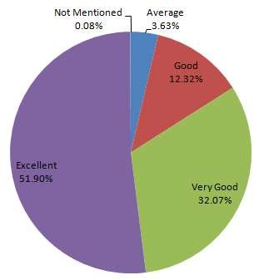
- How much of the syllabus was covered in the class?

- How well did the teachers prepare for the classes?

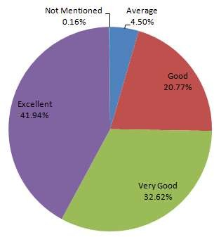

- How well did the teachers prepare for the classes?

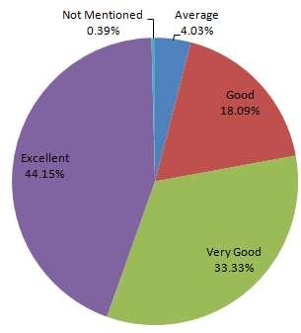

- How well were the teachers able to communicate?

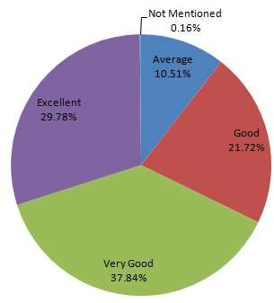

- The teacher’s approach to teaching can best be described as
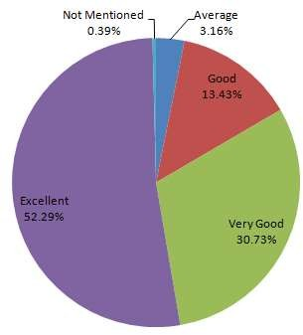

- Fairness of the internal evaluation process by the teachers.

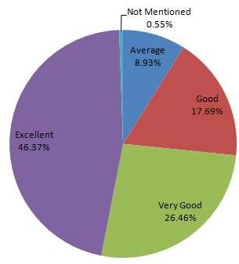

- Was your performance in assignments discussed with you?

- The institute takes active interest in promoting internship, student exchange, field visit opportunities for students.

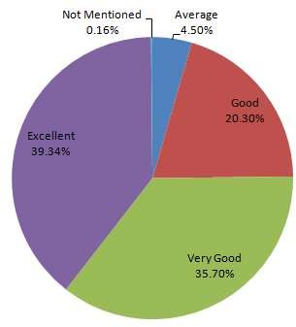

- The teaching and mentoring process in your institution facilitates you in cognitive, social and emotional growth.

- The institution provides multiple opportunities to learn and grow.

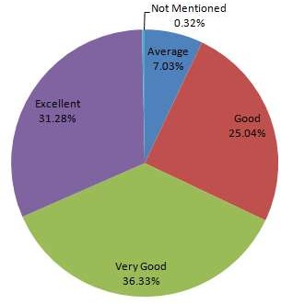

- Teachers inform you about your expected competencies, course outcomes and programme outcomes.

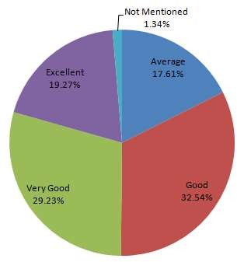

- Your mentor does a necessary follow-up with an assigned task to you

- The teachers illustrate the concepts through examples and applications.

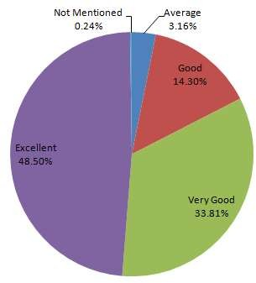
- The teachers identify your strengths and encourage you with providing right level of challenges.

- Teachers are able to identify your weaknesses and help you to overcome them.

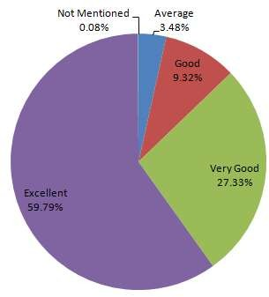

- The institution makes effort to engage students in the monitoring, review and continuous quality improvement of the teaching learning process.

- The institute/ teachers use student centric methods, such as experiential learning, participative learning and problem solving methodologies for enhancing learning experiences.

- Teachers encourage you to participate in extracurricular activities.

- Efforts are made by the institute/ teachers to inculcate soft skills, life skills and employability skills to make you ready for the world of work.

- What percentage of teachers use ICT tools such as LCD projector, Multimedia, etc. while teaching.

- The overall quality of teaching-learning process in your institute is very good

